PEAK System
In March 2010, the Office of the Secretary of Defense (OSD), U.S. Southern Command (USSOUTHCOM), and the National Defense University (NDU) partnered to form the PEAK JCTD (Joint Capability Technology Demonstration) to address the following problem statement:
USSOUTHCOM's capability for promoting security and enhancing stability within its geographic area of responsibility is constrained by a limited capacity for enabling scalable critical services during time-sensitive events.
Authorities in theater often lack the capacity to develop or repair essential services in times of crisis. During the first days of a natural or man-made crisis, the Department of Defense and partner nations want to improve their ability to provide critical services through a structured process involving public and private, government and trans-national participants. These collaborative efforts would contribute to regional stability.
The goal of this project is to conduct research of existing designs and products that make maximum use of commercial off-the-shelf technology for the PEAK JCTD. The operational-user community has identified four primary desired capabilities (water, power, local situational awareness, and communications) and several supporting tasks/attributes to resolve the operational problem.
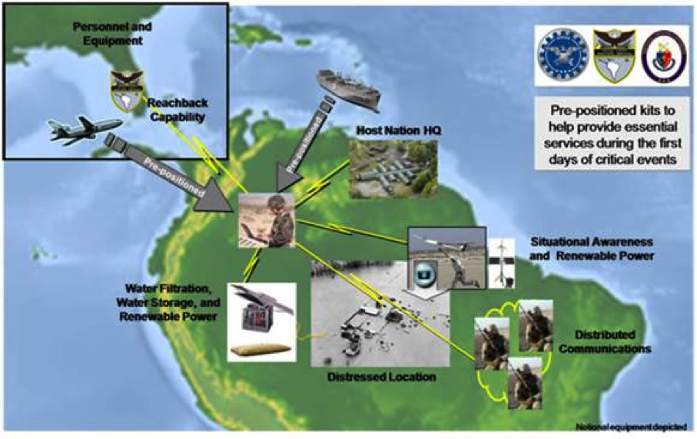
See Appendix A for a full description of this diagram.

Stakeholder Expectations
The system must have the following attributes:
- Utilizes commercial-off-the-shelf technology with limited development
- Easy to operate and train
- Low maintenance and sustainment requirements and costs
- Exportable to foreign nations
- Non-proprietary technology
- Light weight (man portable)
- Durable and weather resistant
- Limited HAZMAT requirements
- Transportable by military and civilian air, sea, and land modes
- Completed kit and consumables must fit on a single 463L cargo air pallet
The water purification equipment must be capable of producing potable water from fresh, brackish, or salt water and must abide by the following parameters:
- Includes filtration system, distribution capability, and storage container
- Provides potable water for drinking and hygiene
- Powered through the kit power generation system
- Leverages existing technology
The power sub-system must primarily run on renewable sources and retain the following properties:
- Provides power to the components of the kit
- Power is generated through renewable resources (solar, wind, etc.) with a fossil fuel generator backup
- Has sufficient capacity to support all components of the kit simultaneously
- Leverages existing technology
Local situational awareness, including information sharing on threats, population, services, the environment, infrastructure, and other support personnel, needs to provide time-sensitive information quickly to first responders and decision makers. It should adhere to the following guidelines:
- An unmanned aerial system, control device, camera (still or motion), and platform is needed to view images of environments, infrastructure, and so forth
- Integrates with system
- Power through the kit power generation system
- Leverages existing technology
The communications sub-system should operate on the local, national/regional, and international levels in order to transmit/receive voice and data communications. The following parameters should be met:
- Consists of a communication device that transmits voice and data over a low-bandwidth network
- Enables personnel to communicate situation reports with authorities and other aid personnel
- Integrates with situational awareness component of the kit
- Powered through the kit power generation system
- Leverages existing technology

Appendix A

This image is a stylized map of South America used to illustrate the deployment of emergency response resources during critical events. The map is overlaid with icons, arrows, and labels that represent various capabilities and services positioned across the continent.

In the top left corner, there is an icon of an airplane labeled "Personnel and Equipment", connected by an arrow to a nearby label called "Reachback Capability", indicating logistical or remote support.

At the center of the map, a cluster of buildings and people is labeled "Host Nation HQ", representing the central coordination point for operations.

To the right side, there are icons for "Situational Awareness" and "Renewable Power", suggesting the use of surveillance and sustainable energy sources in the field.

In the bottom right corner, a set of communication devices is labeled "Distributed Communications", indicating mobile or decentralized communication systems.

At the bottom center, a yellow-highlighted area labeled "Distressed Location" shows a damaged zone with debris, representing the area most affected by the crisis.

To the bottom left, icons for "Water Filtration", "Water Storage", and "Renewable Power" are shown, indicating the deployment of clean water and energy solutions.

A text box on the right side of the image reads:
"Pre-positioned kits to help provide essential services during the first days of critical events."

The image also includes logos of various supporting organizations, suggesting a collaborative, multi-agency response effort.

